Precious metals: on the edge of a recovery

February 5th, 2014

Introduction

After a 2 and a half consolidation, it looks like precious metals have entered in a bottoming process, says Cyril Berkouk of Trading Central. Technical indicators are showing reversal signs while a bullish pattern is taking shape. Furthermore, short contracts on CFTC are at a record high providing a very interesting situation from a contrarian point of view.

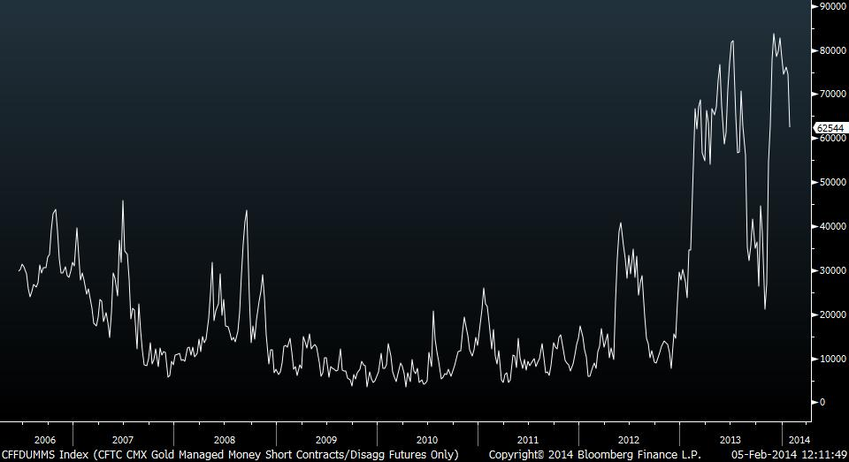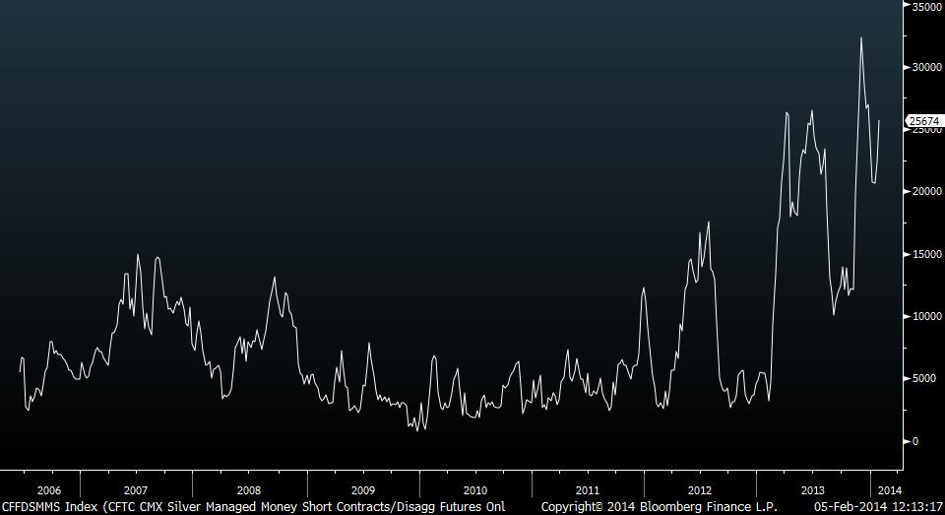
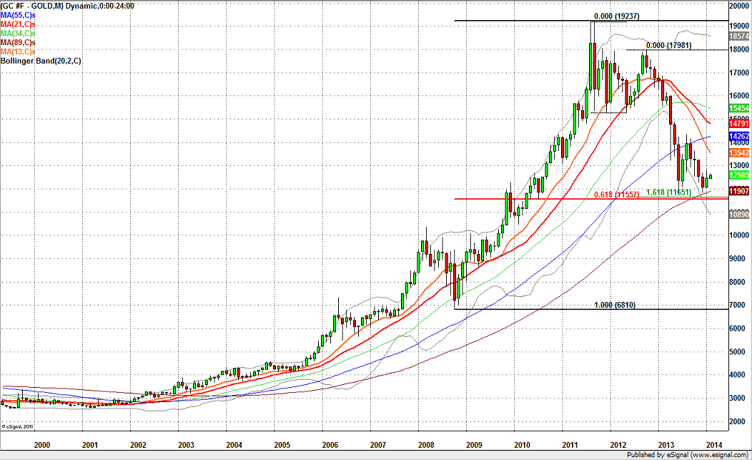
Gold is shaping a base around 61.8% Fibonacci retracement of the 2008-2011 bullish run
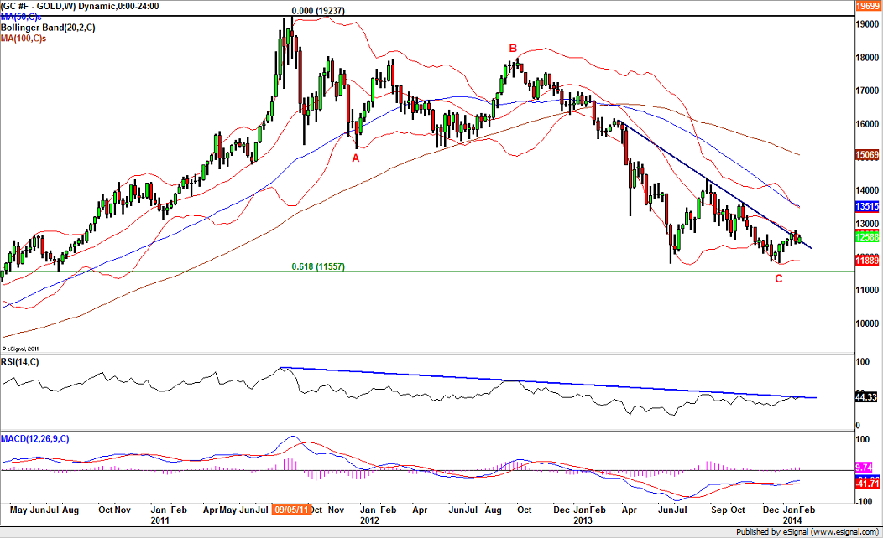
A large A-B-C consolidation which should come to an end since Gold is challenging a key resistance area.
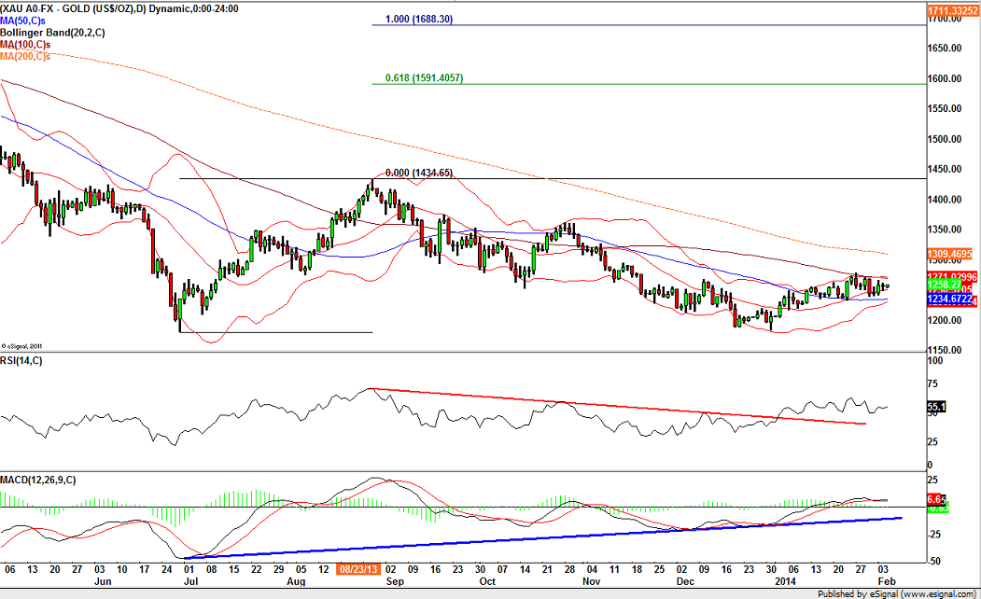
Gold is shaping a reverse Head & Shoulders (bullish pattern). The daily MACD is supported by a rising trend line. The daily RSI has pushed above a bearish trend line.
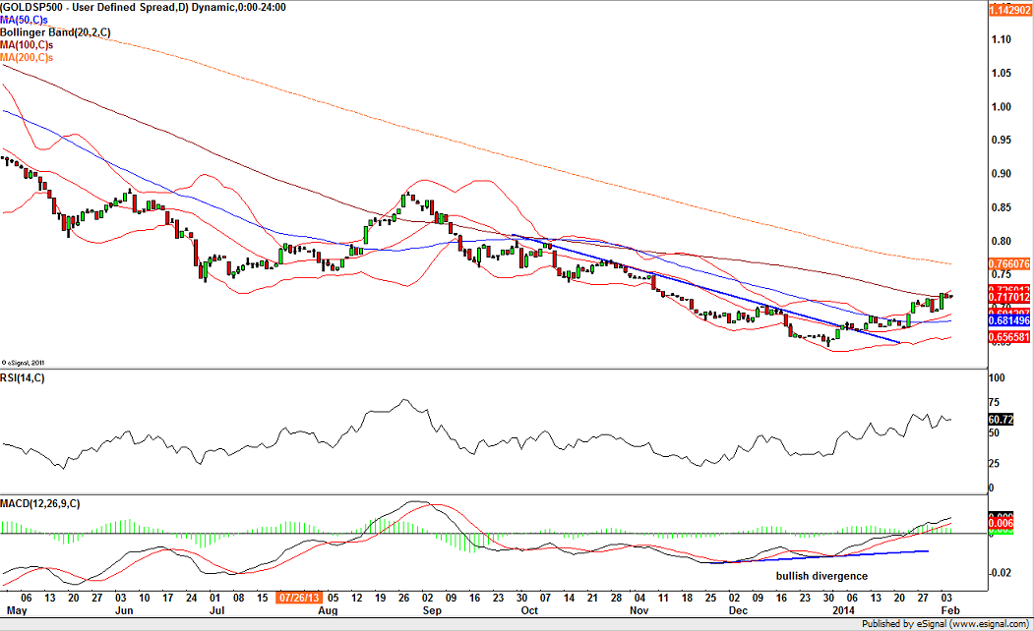
Gold/S&P500 ratio has validated a reverse Head & Shoulders. The 20-day moving average and the 50-day moving average have validated a golden cross. The daily MACD has validated a bullish divergence.
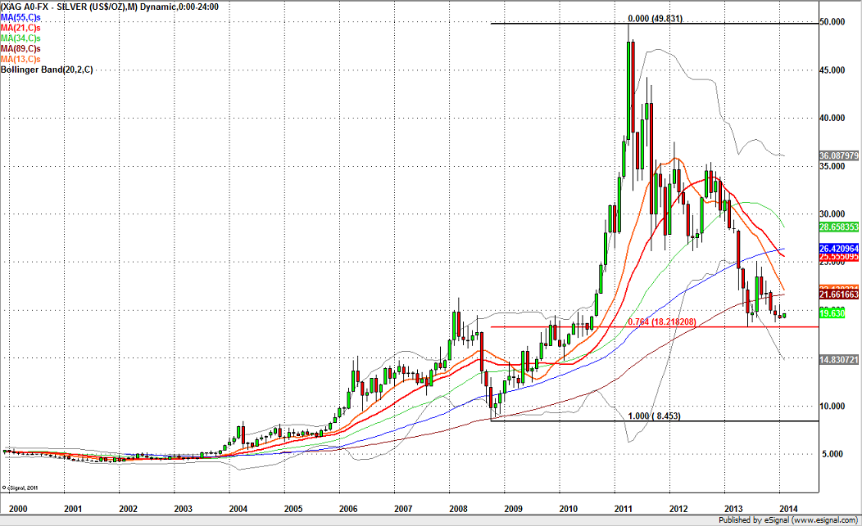
Silver is shaping a strong base around 18.20 which is a key support area since it is matching the 76.4% Fibonacci retracement and a horizontal support.

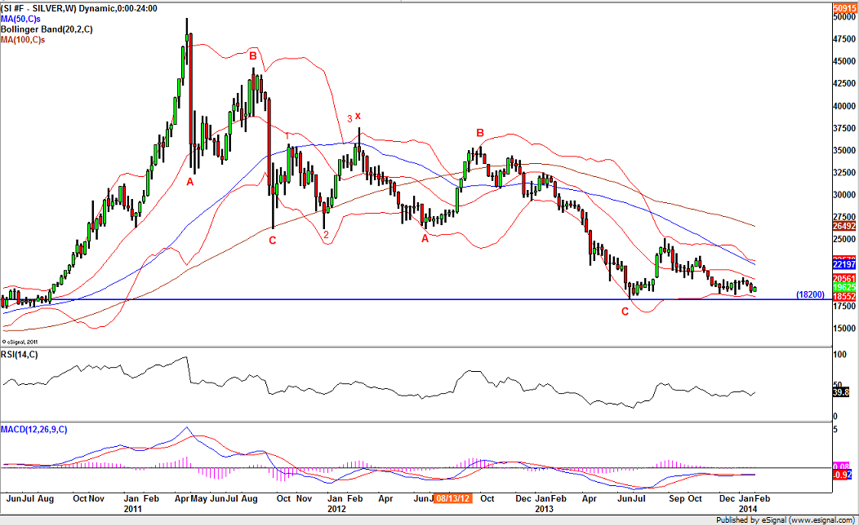
A large consolidation with a double A-B-C consolidation which should come to an end.
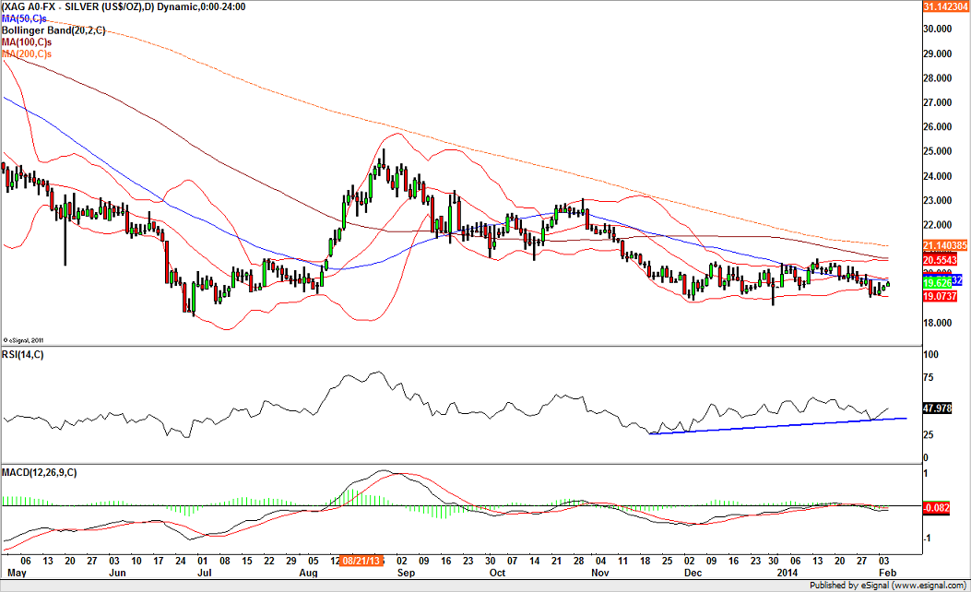
Silver is shaping a reverse Head & Shoulders too. The daily RSI is supported by a bullish trend line.
To sum up:
- Reward/risk ratio is becoming very interesting to initiate long positions now
- Stop loss on Silver is set at 18.20
- Stop loss on Gold is set at 1180

- A come back to the declining 50-week moving average (coming around 1351 this week) can be expected on Gold at first
- A come back to the declining 50-week moving average (coming around 22.20 this week) 26 can be expected on Silver at first
- From our view, a push above the declining 50-week moving average on both Gold & Silver would turn the outlook dramatically bullish.

